**Linux Assignments**

**1. Which command is used to know the current working directory?**

**Ans:** pwd

**2. How would you find out its contents?**

**Ans:** cat > file.txt

Hello

Linux

**3. Identify the commands with inputs to do the following**

**a. Create a directory dir**

**Ans:** mkdir dir1

**b. Create a subdirectory d2 in d1**

**Ans:** mkdir -p d1/d2

**c. Change to directory d2**

**Ans:** cd d2

**d. Create an empty file “f1.txt”**

**Ans:** touch f1.txt

**e. Display the contents of “f1.txt”**

**Ans:** cat f1.txt

**f. View the contents of d1 from current directory d2**

**ans:** ls

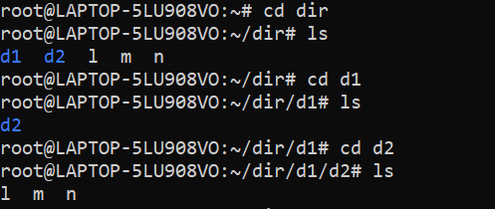

**4. Use the ls command with its options. How will you identify directories from the**

**listing?**

**Ans:** ls

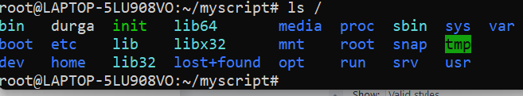

**5. Use ls to do the following**

**a. List files with single character names.**

**Ans:** touch a b

ls ? => a b

**b. List hidden files also. [ Note : Hidden files are files having name started**

**with a “.” ]**

**Ans:** ls -a => . .. f1.txt

**c. Suppose there are files tb1.1, tb2.1, tb3.1, ….tb10.1. Write command to**

**list all the files [Hint: use wild card characters]**

**Ans:** touch tb1.1, tb2.1, tb3.1, ….tb10.1

**6. Write the command to list all files in descending order of their size.**

**Ans:** ls -laS

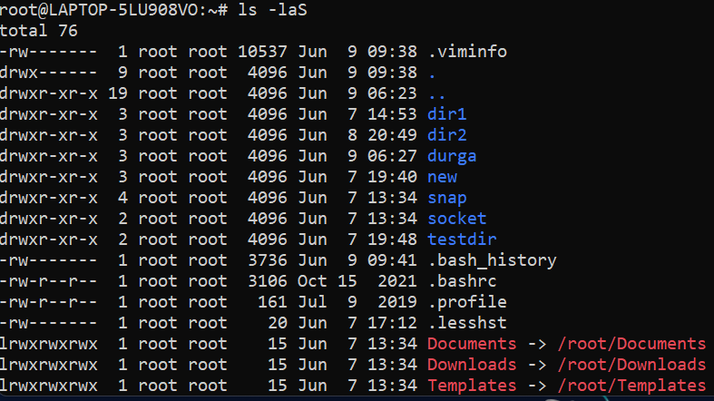

**7. Suppose there are files temp1, temp2, temp3. Write command to remove the files**

**without listing them explicitly**

**Ans:** cat > temp1

cat > temp2

cat > temp3

rm temp1

rm temp2

rm temp3

**8. Which command is used to list top few lines in the file?**

**Ans:** cat > nm.txt =>12345..12

head nm.txt =>12345…10

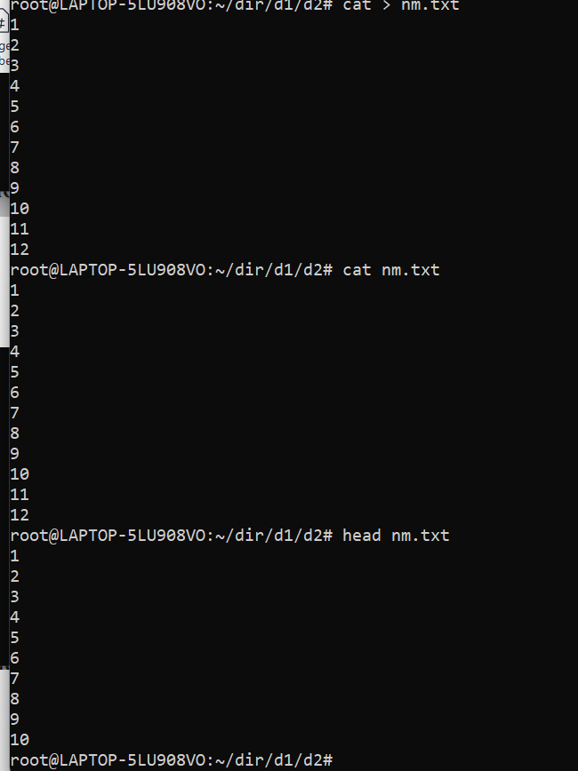

**9. Create a directory “testdir”**

Ans: mkdir testdir

cd testdir

**10. Use cp command to do the following**

a. Copy the file tb1.1 (created above) in the same directory.

Ans: cp tb1.1

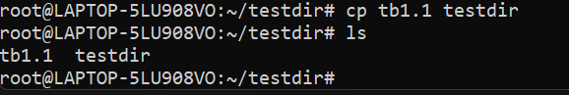

**b. Write a command to copy all the files i.e tb1.1,tb2.1,tb3.1,…..tb10.1 in a**

**new directory –“new”**

Ans: touch tb1.1,tb2.1,tb3.1,…..tb10.1

mkdir new

cp tb1.1,tb2.1,tb3.1,…..tb10.1

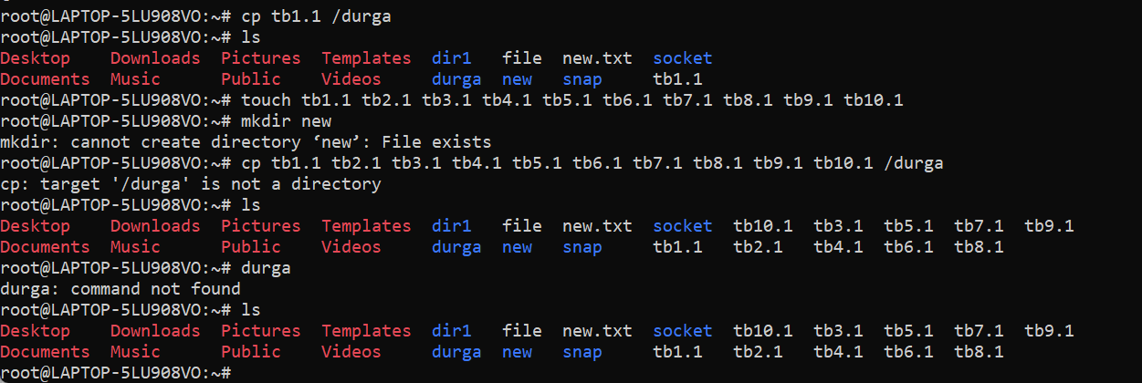

**c. Create a subdirectory in new in named“new1”.**

Ans: mkdir -p new/new1

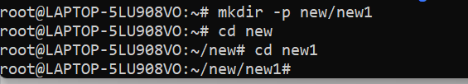

**d. Write a command to copy selectively only tb2.1, tb6.1, tb7.1 and tb10.1 in**

**the directory new1.**

Ans: mkdir new1

cp tb1.1,tb2.1,tb3.1,…..tb10.1

**e. Write a command to copy the entire directory “new” to a directory**

**“newprogs”. [Note : use the –R option of “cp” command ]**

Ans: cp -R

**11. Find out the difference between**

**a. “mv” & “cp”**

Ans: **mv:** To move files and directories from one directory to another or to rename a file or directory.

**cp:** Copies the file.

**b. “rm”, “rmdir”**

Ans: rm: To remove the files

rmdir: To remove directory

**c. “mkdir” and “mkdir -p”**

Ans: mkdir: To create a new directory

mkdir -p: To create multiple directories within the directory.

**12. Use a single command rmdir once to remove “testdir” and all its sub directories**

**and files created above.**

Ans: rmdir testdir



**13. Which command is used to get the manual information of a command?**

Ans: man touch

**14. If you are not able to change to a directory what could be the likely cause?**

Ans: It may happen that you are trying to cd into a file. The same message is thrown then. This may happen when something that you think should be a directory, is a file in reality. Well, Permission denied and Not a directory are different errors, and both describes what's wrong pretty clearly.

If you receive an error telling you that you do not have permissions to create a directory or to write a file to a directory then this is likely an indication that your script is attempting to write to a directory that the user running the build does not own.

**15. Explain the differences among the following commands:**

**a. cd / :** This command is used to change directory to the root directory, The root directory is the first directory in your filesystem hierarchy.

**b. cd .. :** This command is used to move to the parent directory of current directory, or the directory one level up from the current directory. “..” represents parent directory.

**c. cd :** Change directory

**d. cd ../.. :** To go to two times of parent folder.

**Advanced Optional Questions**

1. How could you display the inode number of a file?

Ans: ls -li

1. **What is the pipe symbol? What effect does it have?**

Ans: A Pipe is a form of redirection (transfer of standard output to some other destination) that is used in Linux and other Unix-like operating systems to send the output of one command/program/process to another command/program/process for further processing. The Unix/Linux systems allow stdout of a command to be connected to stdin of another command. You can make it do so by using the pipe character **‘|’**.

Syntax: command_1| command_2

1. **3. Find out the details of “ps” command ?**

Ans: ps command is used to list the currently running processes and their PIDs along with some other information depends on different options. **It reads the process information from the virtual files in /proc file-system**. /proc contains virtual files, this is the reason it's referred as a virtual file system.